CLEO®/Europe-EQEC 2017, One Page Summary Template

(Title should be centred 14 pt bold type, with Title Case

**Formatting - Elements, and Acronyms Should**

**Be Capitalized)**

**Author name(s) [10-point type, centred, bolded]**

*Author’s affiliation and full address (8-point type, centred, italicized)*

***Patrick Brown***1***, Oliver Miller***1***, Alina Binari²***

*1. University of Paris Sud, 15 rue Clémenceau, F-91400 Orsay, France*

*2. Università Politecnica delle Marche, IT-* *60131 Ancona, Italy*

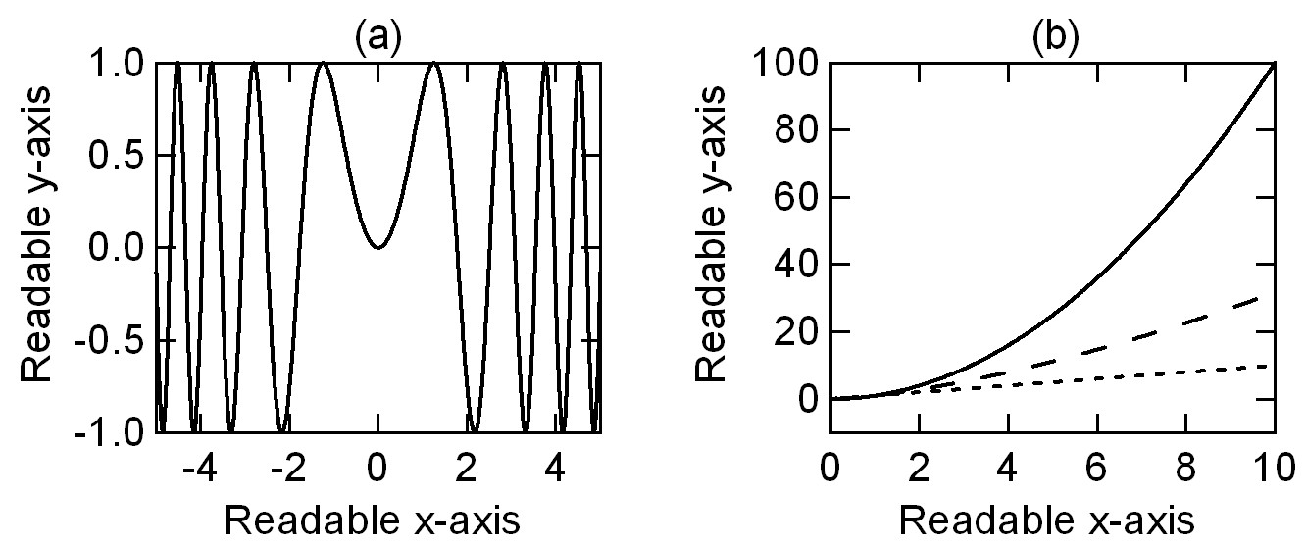

**Fig. 1** The abbreviation “Fig.” (for figure) should appear first, followed by the figure number, a period, and then the figure caption.

**Example References**

[1] **J. Itatani, D. Zeidler, J. Levesque, D. M. Villeneuve, and P. B. Corkum,** "Controlling High Harmonic Generation with Molecular Wave Packets," Phys. Rev. Lett*.* **94**, 123902 (2005). For journal articles, authors are listed first, followed by the article’s full title in quotes, the journal’s title abbreviation, the volume number in bold, page number, and the year in parentheses.

[2] G. P. Agrawal, *Nonlinear Fiber Optics*, 3rd. ed., (Academic Press, Boston, 2001). For citation of a book as a whole: authors, followed by title in italics, and publisher, city, and year in parenthesis.

[3] R. Kienberger and F. Krausz in, *Few-cycle laser pulse generation and its applications,* F.X. Kärtner ed. (Springer Verlag, Berlin, 2004). For citation of a book chapter, authors are listed first, followed by book title in italics, editors, and publisher, city, and year in parenthesis. Chapter number may be added if applicable.